Setup Eclipse (RDi 9.5) for JCRCMDS

# Prerequisites

Installed IBM Rational Developer for i (RDi 9.5).

# Repository Location at SourceForge:

ssh://tools400@git.code.sf.net/p/jcrcmds/code

# Ant Setup

Retrieve the path of the Ant runtime of your RDi installation:

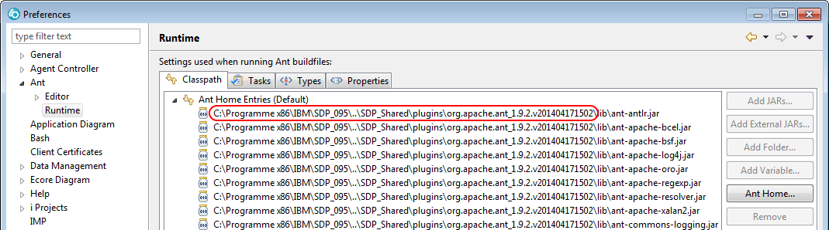

In the example above that is:

c:\Programme x86\IBM\SDP_Shared\plugins\org.apache.ant_1.9.2.v201404171502\

For WDSCi use:

c:\Program Files (x86)_IBM\SDP_070_Shared\plugins\org.apache.ant_1.6.5\

Add the ANT_HOME environment variable to your Java build path:

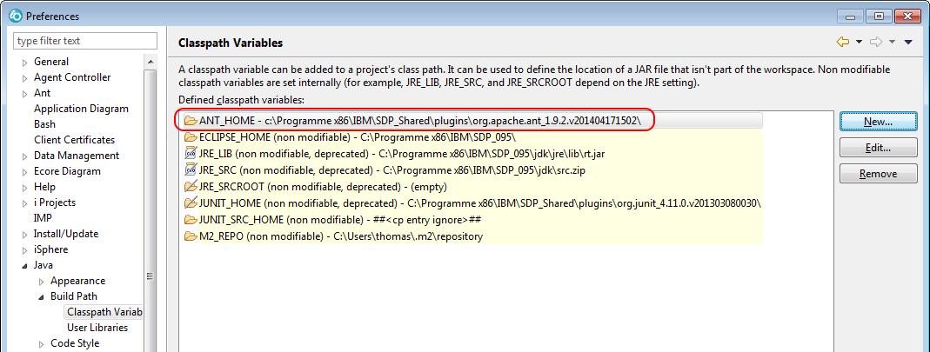

# Java Setup

Set the Java compiler compliance level to 1.5, because WDSCi is shipped with a Java 5 runtime:

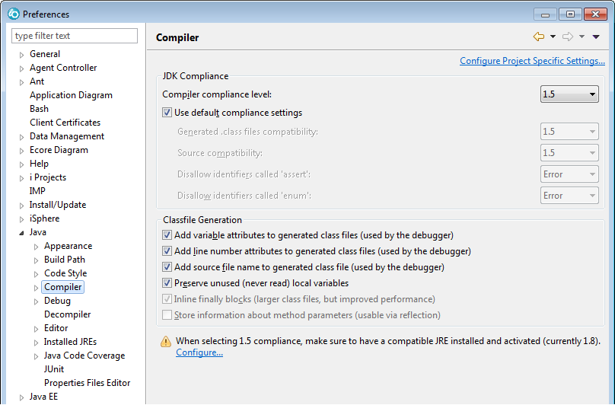

Add the WDSCi Java runtime to your RDi Java JREs and make it the default JRE:

Name: JRE 1.5.0 IBM J9  
Path: c:\Programme x86\IBM\SDP_070\jdk\jre\

The above path to the WDSCi JRE is nothing more than an example. For sure it is different on your computer.

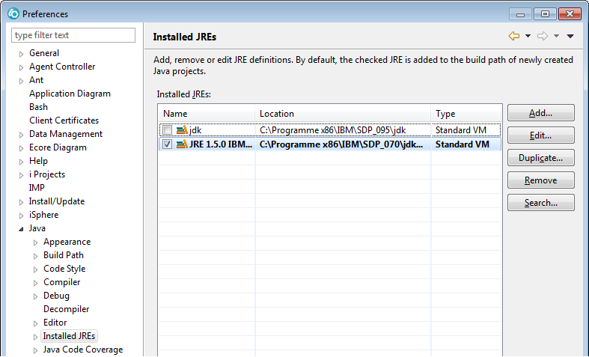

Import the JCRCMDS Clean Up profile from the JCRCMDS Setup project:

[workspace]\JCRCMDS Setup\Preferences\Java\Code Style\CleanUp\Preferences_Java_CodeStyle_CleanUp (JCRCMDS).xml

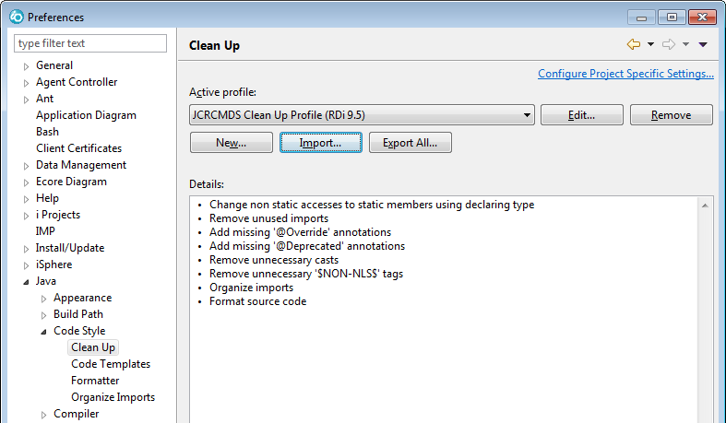

For WDSCi, restore default values for all "Clean Up" tabs. Uncheck "Change all accesses through subtypes" on the "Member Accesses" tab:

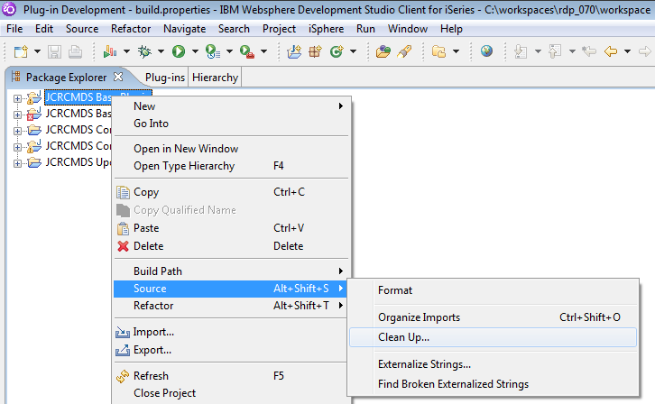

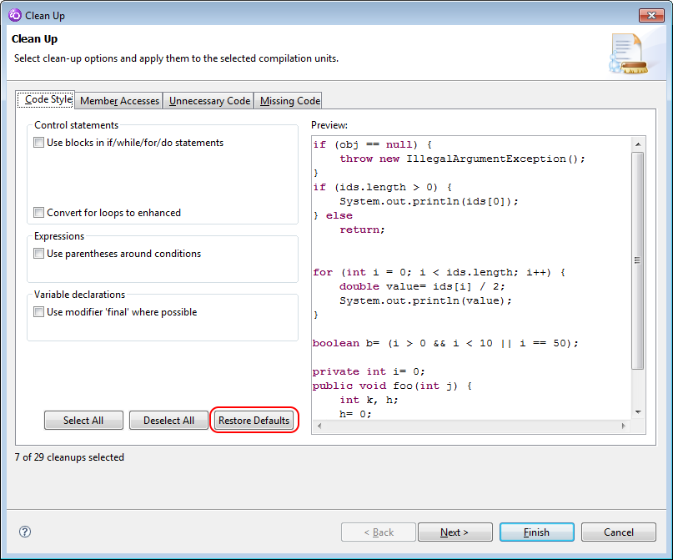

Import the JCRCMDS Formatter profile from the JCRCMDS Setup project:

[workspace]\JCRCMDS Setup\Preferences\Java\Code Style\Formatter\Preferences_Java_CodeStyle_Formatter (JCRCMDS).xml

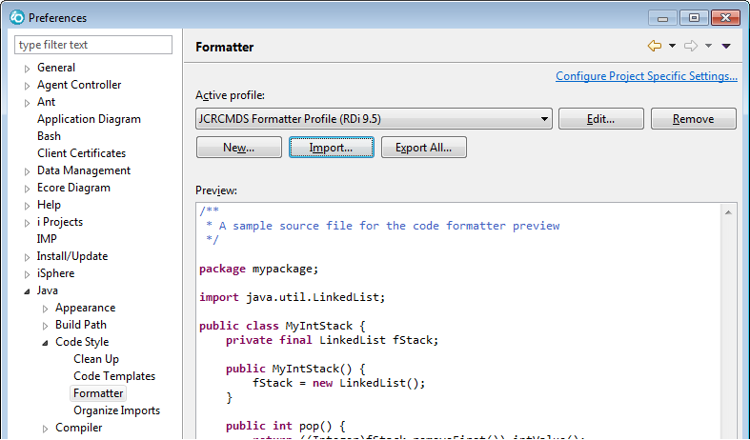

Import the JCRCMDS Code Templates from the JCRCMDS Setup project:

[workspace]\JCRCMDS Setup\Preferences\Java\Code Style\Code Templates\Preferences_Java_CodeStyle_Code_Template (JCRCMDS).xml

Verify the Java Save Actions and make sure they match the following values:

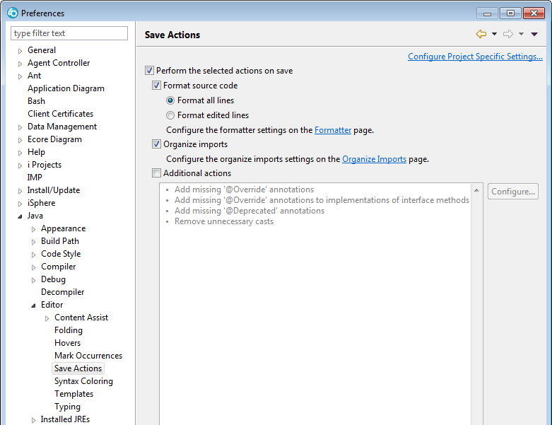

# Debug/Run Configuration

It is strongly recommended to enable Java assertions and to specify the language profile of the Eclipse test application, when you test the JCRCMDS plug-in.

* * * M I S S I N G * * *

# Other Usefull Settings

Enable the heap status:

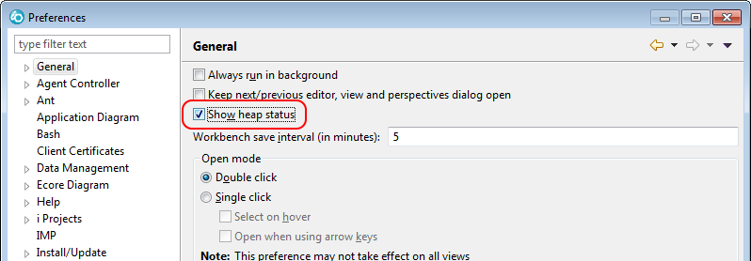

Disable Spell Check on slow computers:

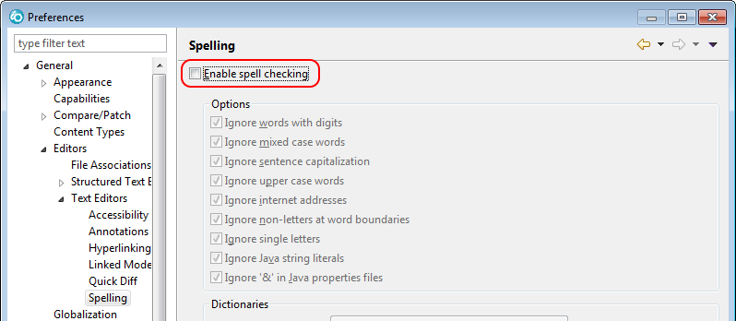

Enable Ctrl+Backspace for Undo operations, if you like that. Filter for UNDO and copy entry "Ctrl+Z" to "Ctrl+Backspace":

